**Amazon Mobile Automation**

**Benefits of using Automation over Manual**

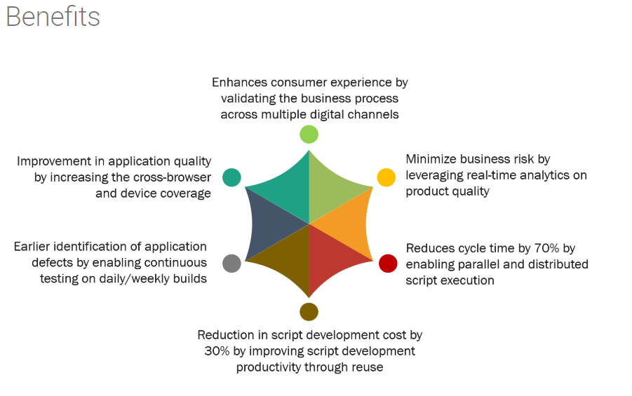

**Framework Components** :

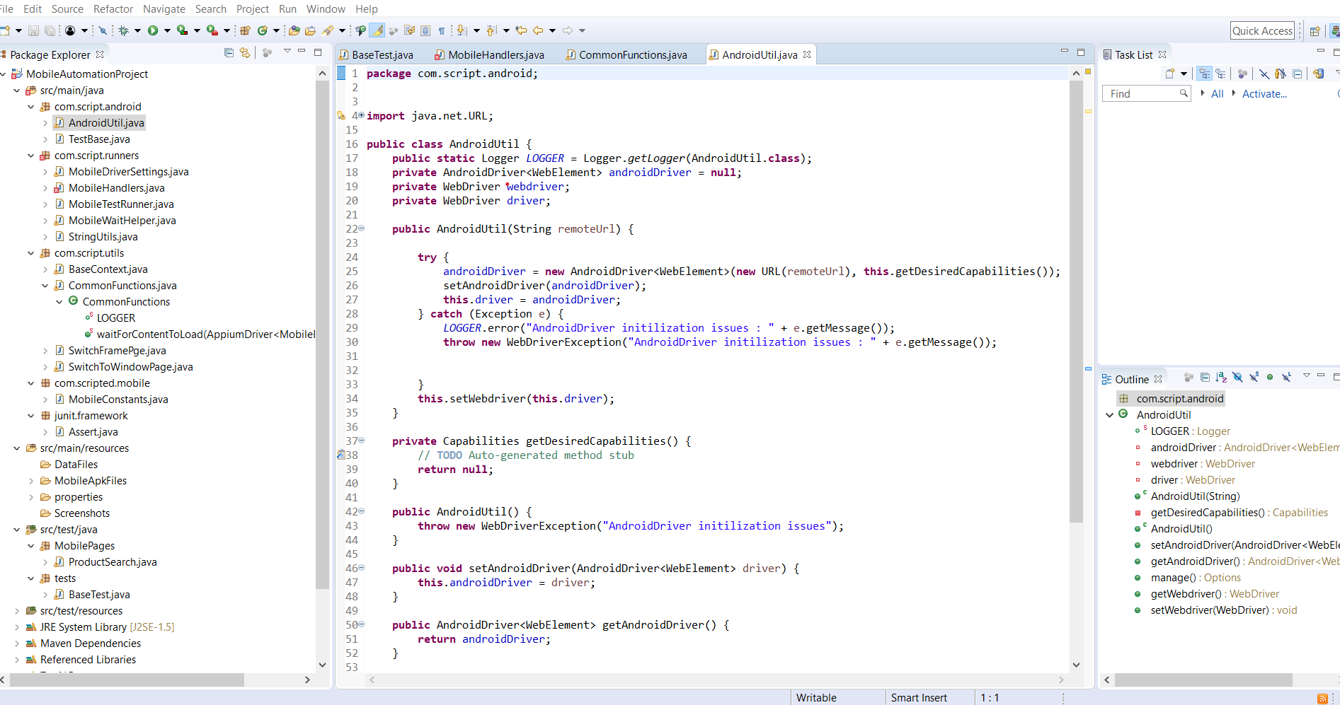

**The Following explains the structure in detail:-**

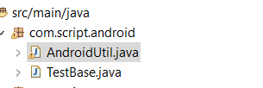 :

1. It is the main package, it consists of all the Desired Capabilities for the Android device

**2.:** All the generic java file used by the project as defined in this project.

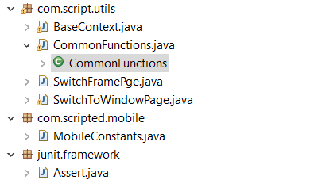

**Com.script.Android** : Any configurations related to Mobile, can be done under this package

Ex - generic java files

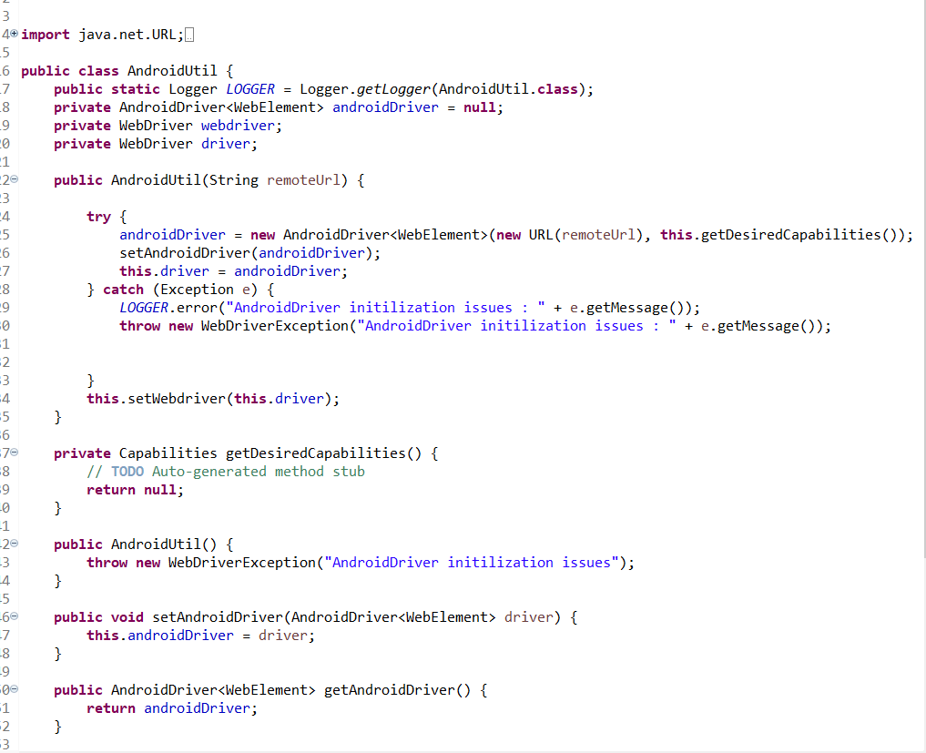

**Com.script.Runners:** Generic java files and Re-useful components are placed in this package

Like Scroll, Swipe, Screenshots and Image resolution

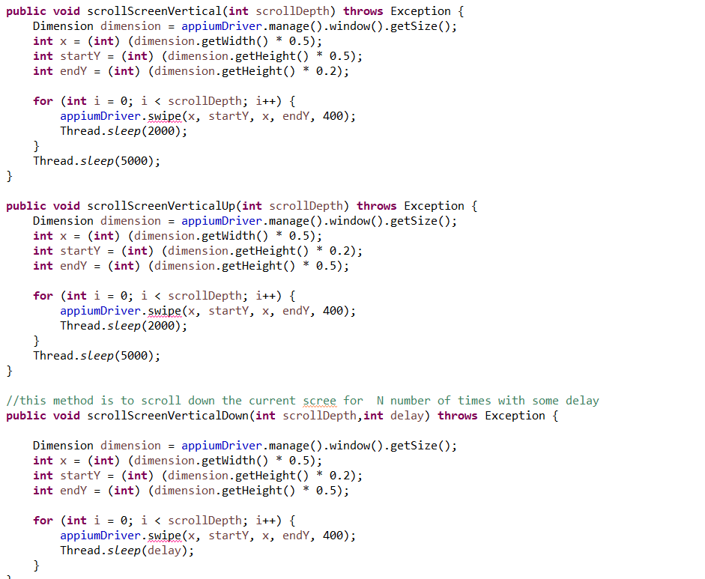

**Com.script.Utils :** This package consists of Common Functions used across the framework and

Handling frames etc.

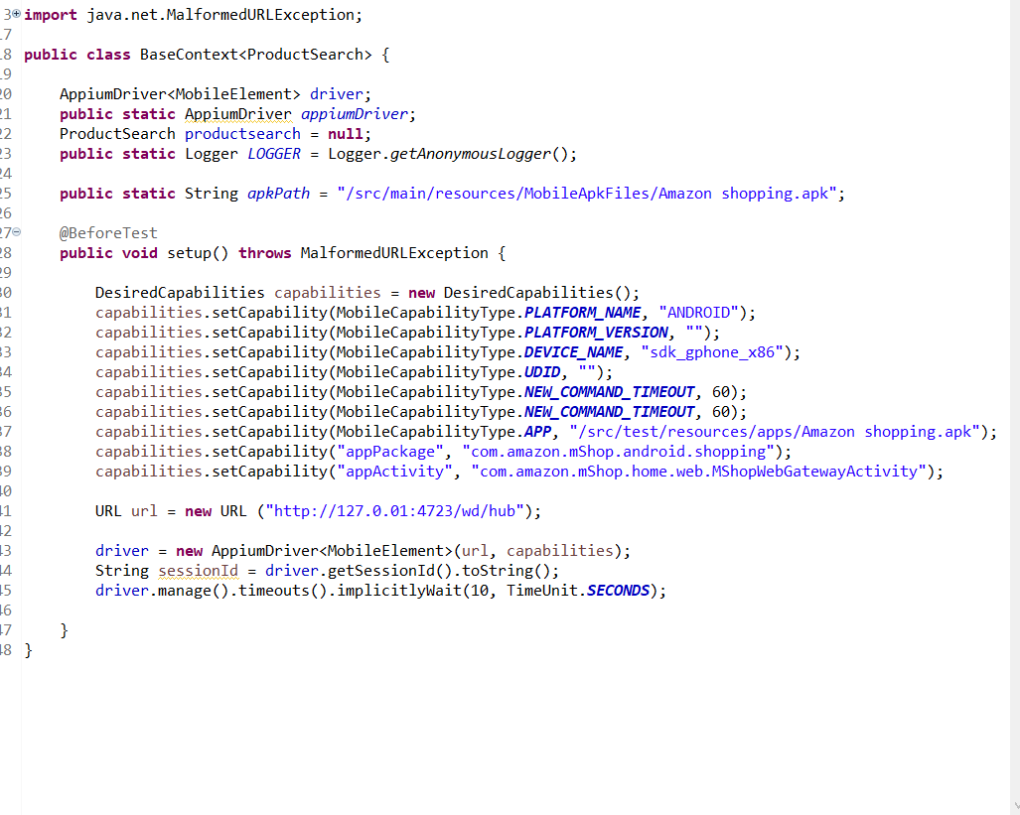

**AndroidDeviceSettings.java**: In this file all the Android related capabilities to run on the real device/emulator setting are done

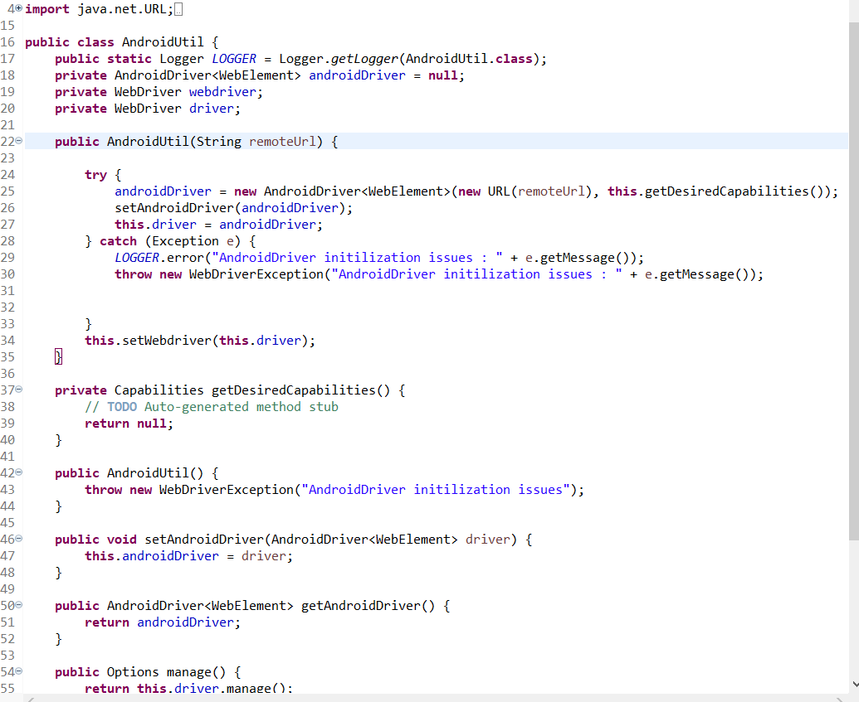

**AndroidUtil.java** : Android driver and Web driver settings are done in this file

**AppiumSettings.java** :This file consists of Appium Server start and stop methods, It also contains methods related to get the device details and check if the Appium server is running.

**MobileHandlers.java** : All the reusable methods are defined in this java file.

**MobileWaitHelper.java** : All the wait methods are defined in this java file.

**TestBase.java** : In this file we are setting and getting the parameter for white label and technology

**src\main\resources** consists of Lib folder in which android jar file is placed

**pom.xml** : This xml file consists of log 4j, java binding , selenium , java client dependencies

**pom.xml** : Allure, testNG, Extent report, commons configuration dependencies

**5.**: All the project execution files are placed in this package

**src\main\resources** : This package consists of Test Data file, Drivers required to run the scripts(chromedriver.exe), Log 4j properties file, Mobile configurations properties files

**Src\test\mobile** : This package consists of sub packages :

**Com.scripted.Pages**: This package consists of page object model - mobile elements and methods/functions of all the pages in the application which are required to run the scripts.

**Com.scripted.BusinessMissions:** It consists of all the business classes

**CommonFunctions** java file all reusable functions are defined in this file.

**JRE System Library : It consists of all the java jars required to run the application**

**Maven Dependencies : It consists of all the maven dependency jars downloaded**